A Systematic Review of Maternal mortality and appalling malady during the postpartum time.

**Abstract:** Maternal health is crucial for the well-being of mothers and their new-borns, and many maternal deaths can be prevented. In this report, as a data scientist working with the clinicians, maternal health data was analysed objectively. Specific evidence-based actions were identified to improve health outcomes. The analysis included building a linear model, applying principal component analysis, investigating the relationship between age and heart rate, analysing associations between diastolic and systolic blood pressure, and identifying clusters of patients with similar Systolic BP. The analysis revealed the importance of regular monitoring of blood pressure, promoting healthy lifestyles, timely interventions, and continuous professional development to improve maternal health outcomes. Feedbacks from this report could proffer solutions to policymakers, healthcare providers, and researchers working to improve maternal health outcomes.

# Introduction

Almost 295,000 global pregnancy related fatalities were reported by the World Health Organisation in Geneva (2019), an equivalent to the maternal mortality fraction of 211 per 100,000 live births. Due to cumulative drops within years 2000 to 2017, it was anticipated that there would be a more significant reduction in maternal death by 2017 by 35% margin. It was actually discovered that the death rate increased especially in most low-middle income countries within sub-Saharan Africa and southern Asia (Ronsmans et al., 2006). There is evidence that this chronic incidence is rising in some high-income countries, mostly among vulnerable populations (Dol et al, 2022).

Furthermore, not much is known regarding timing patterns during the first 42 days after delivery, making it harder to determine when closer monitoring is necessary to further cut down on mortality. A research study carried on the possible causes of maternal deaths in 2012 shows that 73% of maternal deaths were as a result of poor obstetric negligence such as haemorrhage, uncontrolled hypertension, sepsis and other related factors. It was discovered that 40% to 45% of the cases occurred between the start of labour and 24-hour post birth respectively. Majority of these evidence pointed to that fact that the LMICs are mostly exposed to these risks during the postpartum periods (Dol et al, 2022).

This growing concern on severe maternal fatalities and associated complications demands strict investigation, critical approaches and mitigating procedures to ensure that appropriate, suitable, high-quality care driven solutions are given to our mothers in a timely manner for improved results.

The Objective of this report is conduct a comprehensive analysis on the possible causes of maternal deaths, explore further contributing factors with regards to the given datasets and make profound contribution and recommendations vis a vis the substantial discoveries

made from this systematic review. This will provide some useful insights to cut down on neonatal death rates as well.

# Data and Methods

The dataset labelled mhs was used for this study. The excel file was gotten from Maternal Health database of the World Health Organisation (WHO).Adherence to a quality, well labelled and professionally sourced dataset provided more rooms for assertive analytical opportunities.The dataset consists of 1014 personal details comprising of their ages, systolic and diastolic readings respectively, blood sugar level, body temperatures, heart rates and the risk levels across the given distribution.We discovered two entries with fake heart rates which were consecutively replaced with the mean heart rate at locations 499 and 908. The summary of the statistics is given below in Fig.1.

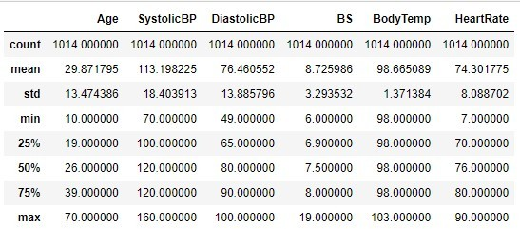

Fig.1

Exploratory data analysis was done in order to gain more grasp on the provided dataset. Binary encoding Label (Deval et al., 2022) was initiated on the risk level to improve the accuracy of our model with an inbuilt space spanning for quantization, encoding, decoding, and loss functions.

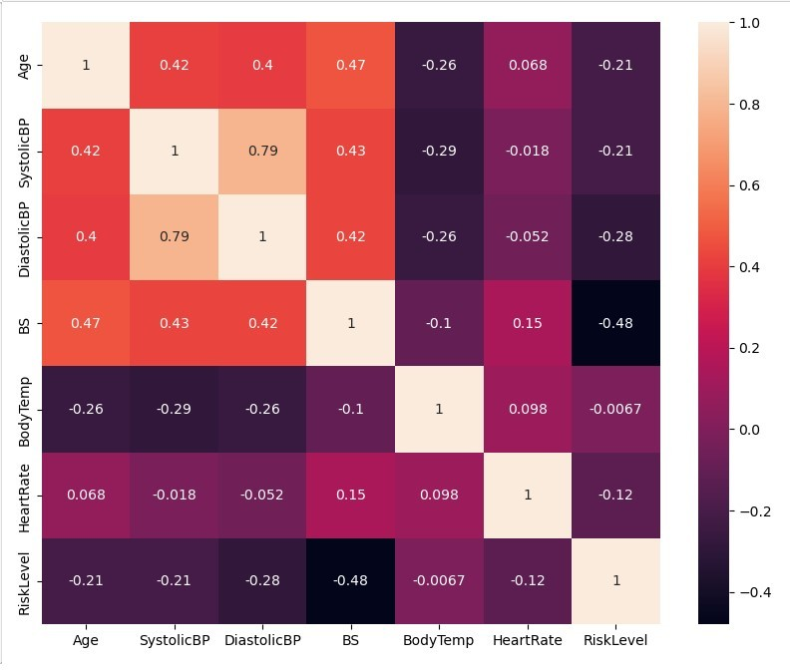

Fig.2

# Analysis and Results

In this section, we considered the following outlined queries to address the above concerns, improve health outcomes and make significant inputs.

* + Build and fit a linear model with response variables backed with justifications.
  + Apply the principal component analysis (PCA) to reduce number of variables.
  + Investigate the relationship between age and heartrate by means of age grouping.
  + Effectuate association rules for recommendation.
  + Find clusters of patients with similar Systolic BP.
  + Calculate the correlation between age and systolic BP with interpretations.

# 3.1 Linear Regression Model

The connection between Systolic BP and exploratory factors was examined using linear regression (LR) with a splitting ratio of 80:20 at 42 random states. LR is usually applicable in supervised learnings where there is a linear relationship between data points and focus lies on the 2 or more variables with numerical inputs (Dethlefs, 2023). DiastolicBP, age and blood sugar level were the selected features for this study as demonstrated in the heatmap shown in Fig.2 below. This is because of the high correlation existing between these variables with the dependent variable (SystolicBP). Each of the variables are then transformed in a manner which enables compatibility within the set (Buyrukoğlu & Akbaş, 2022). Due to this inherent similarity among the sets, it becomes a stringent component for the model. Fig.3 below illustrates the error function of the model.

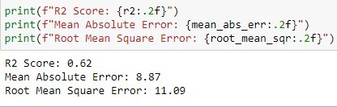

Fig. 3

From the above figure, we got a coefficient of determination of **0.62**. It implies that the measure of success of predicting the dependent variable from the independent variables is 62% slightly above average which is a good fit (Nagelkerke, 1991). The more it tends to 1, the better the model. Also, a root mean square error of **11.09** and mean absolute error of

**8.87** were observed.

# Principal Component Analysis (PCA)

This unsupervised approach was implemented to extract some meaningful information from the sensitive high-dimensional data without losing important details (Kurita, 2020). The

given continuous variables are standardized using standard scaler to ensure uniform contribution to the data analysis. The covariance matrix was initiated to capture redundant information. With the assigned eigenvectors and eigenvalues, the key components were identified as demonstrated in Fig.4 via the elbow point highlighted. From the analysis, we were able to reduce principal components from 5 to 2. As defined earlier, the two components (PC1 & PC2) gave a sense of direction on the data based on the maximal range of variance **(>70)** across the dispersion while considering the order of significance.

Using PCA, we were able to reduce the dimension numbers in the training dataset and Fig.5 demonstrates that we were able to eliminate the error entirely achieving a coefficient of determination of **1** with zero absolute mean error. This is because PCA was done by locating the features which explain the greatest variance thus, capturing core information and omitting noise.

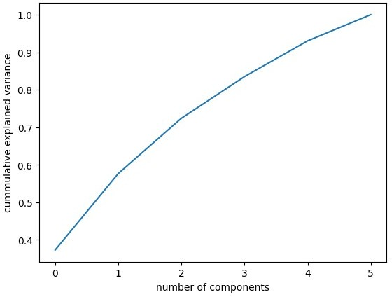

Fig.4

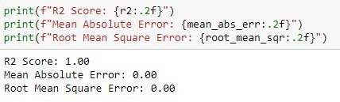

Fig.5

# Heart Rate by Age Distribution

Many studies have been done on heart rates across age ranges. According to Reardon et al. (1996), which concludes that aging process minimizes the global measure of Heart Rate Variability as a result reduces the responsiveness of autonomic activity to external environmental stimuli with time. An interval of 5 years was given to enable us to capture the expected pattern of heart rate changes across the lifespan, while also ensuring that each interval contains a reasonable number of observations.

It could be noticed three (3) spikes on the heart rates across the age classes with the highest around 45-50 see Fig. 6. Probably these might be possible outcomes of some undisclosed factors such as ill health, declining libido, mental stress. The mean heart rate is displayed in Fig.7 below.

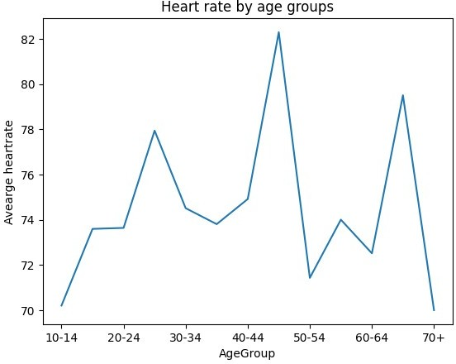

Fig.6

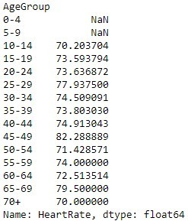

Fig.7

# Recommender System for Blood Pressure Management Learning Environments Using Association Rules

* + 1. **Apriori Algorithm and Association Rule Mining**

An approach to data mining called association rule mining was used to compares two sets of itemset for our investigation (Agrawal & Srikant, 1994). This sequence follows the order of two apriori which stated:

* + - * If a given itemset is supported (or “interesting”), then all its (non-empty) subsets are also supported (or “interesting”).
      * If a given itemset not supported (empty), then all its supersets are also not supported (empty).

Having created the candidate itemsets by expanding the larger itemsets as displayed in table 1. The above hybrid algorithm is fundamentally performed to pull out significant discoveries and ideas from the uncoordinated data while paying strict attention to the following metrics.

* + - * Support commonly defined as a fraction of interactions that contain an itemset. Expressed as Support (X =>Y) = (No of Interactions containing both X and Y/No of Total Interactions) where X is the antecedent and Y is the consequent.
      * Confidence which gives the reliability defined as the percentage of interactions supporting the rule out of all transactions supporting the rule body. This is ration of frequency of X and Y to the frequency of X designated in percentage.
      * Lift denotes factor by which the confidence exceeds the expected confidence. Normally indicated as Lift = (Support [X and Y])/(Support[X] * Support[Y]). It gives dependency to the itemsets.
      * Conviction compares the probability that X appears without Y if they were independent with the actual frequency of the appearance of X without Y. This is expelled as:

Conviction (X =>Y) = (1 - Support [X]) / (1 – Confidence (X =>Y)).

# Measures of Constructs and Design

The 2 blood pressure readings namely systolic and diastolic were used to create the itemsets based on high and low records across the readings. The normal readings were identified within range of 70-90 for diastolic and 110-140 for systolic respectively (See Fig.8).

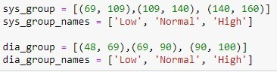

Fig. 8

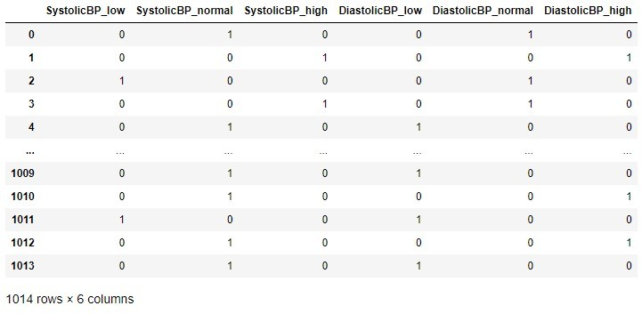

Fig. 9

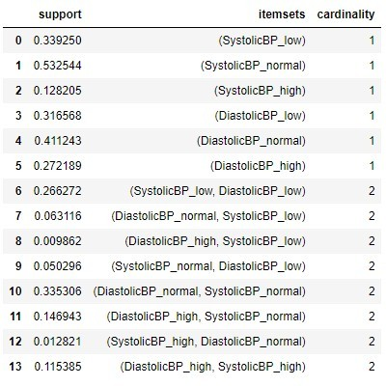

Fig. 10

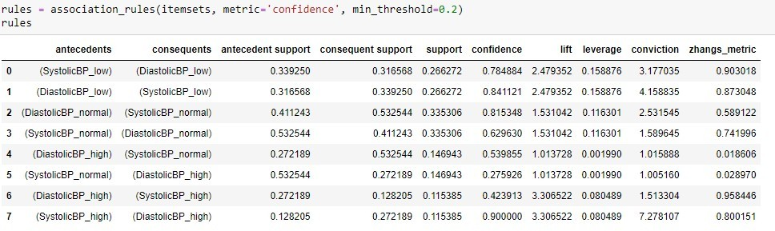

Fig. 11

Fig. 11 presented the association rules to be validated. Scanning through the above details, we could observe that support on item 10 gave the most strength (0.33) across the double cardinality in Fig. 10 while item 8 gave the least strength across the whole cardinality of 0.009862. High systolic and high diastolic gave the highest confidence (0.9) across the sets followed by their respective low and normal at 0.84 and 0.82. Lifts across the rules demonstrated that 6 out of the 8 rules are useful for our prediction with scores greater than 1 ignoring the two with random results. Conviction like lift also shows that there is a reasonable relationship across the 6 associations within the rules.

# Clusters with Systolic BP

In this analysis, we used the k-means clustering algorithm to partition the patients into k clusters based on their systolic BP values. The graph of within-cluster sum of squares (WCSS) against the number of clusters was used to evaluate the quality of clustering via elbow plot

proclaimed in Fig.12 left side. An identified point at **3** represented the optimal number of clusters. This is done to avoid overfitting. Our silhouette and Bouldin scores **0.79** and **0.246** respectively show that the clusters are good and well separated within their data points.

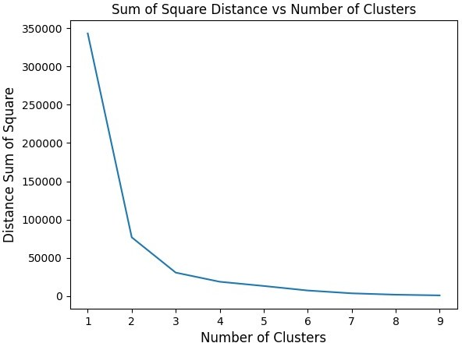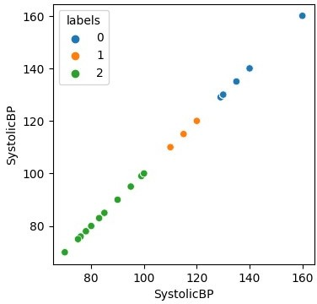

Fig. 12

Fig.13

# Age Correlation with Systolic BP

A correlation coefficient of **0.41** was obtained, which measures the linear relationship between two variables (age and systolic BP). As age increases, the systolic blood pressure tends to rise as well and vice versa. Upshot reveals that there is a common positive linear connection between the two variables. Though this does not imply causation. It does not necessarily mean that age causes changes in blood pressure.

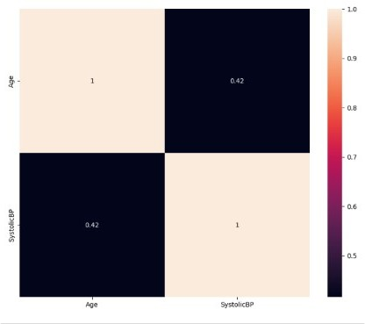

Fig. 14

# Implications

PCA provided a better model fit than the LR because of noise (error) elimination.

Our fact-findings from the aforementioned queries on PCA, association rules, patients clustering, correlation factor have many implications for depth mastery and management of hypertension especially in pregnant women.

High support and confidence measures indicated that the association between diastolic and systolic are quite robust and reliable. Thus, this asserted and brought to the fore the importance of monitoring both readings in clinical practice.

High conviction and lift measures likewise suggested that the noted associations are most likely not to occur by chance and additionally provided evidence for the validity of the relationship between diastolic and systolic blood pressure.

Personalized medical approaches for maternal hypertension management could be improved via the identification of patients' clusters with similar systolic blood pressures. Specific treatment strategies could be deployed to patients within the same agglomeration such as lifestyle adjustment. Clustering analysis can as well proffer latent analytical discernment for hypertension prognosis.

Computation of the correlation between age and systolic blood pressure justifies the well- established link between the two variables. This highlighted the magnitude of age as a risk factor for hypertension. Consequently, there is need for early detection and management of hypertension in older women. Age specific intervention is key.

# Future Research Directions

Supplemental research is required to explicitly examine the underlying techniques involved in the recognized associations between diastolic and systolic blood pressure with regards to patients' genetics, lifestyles and comorbidities.

Exponential learnings on Clustering analysis towards hypertension management using unpredictable controlled trials could be explored to further establish customized therapeutical approaches.

Studies involving optimal BP targets, multiscale relationships between age and hypertension and mitigation strategies need to be reviewed.

Randomized controlled trials examining the impact of lifestyle interventions on BP control and cardiovascular outcomes are essentially required for further bench to bedside learning.

Future investigations via artificial intelligence could enhance hypertension management via predictive simulation, risk classification and automatic individualized treatment recommendations cutting across socioeconomic and scientific horizon respectively.

# Conclusion

This systemic review has provided more personalized medical and public health approach on the effective reduction and prevention of maternal deaths with the special attention to systolic blood pressure. Results from analysis and inquiries shows that the hypertension could be more properly monitored, managed, predicted and prevented if advanced clinical modelling involving PCA, hybrid rules, clusters of BP targets including undisclosed details and other socioeconomic features are considered. Hence, maternal fatality will be reduced immensely when predictively addressed as stated earlier.

# References

Agrawal R. & Srikant R. (1994) Fast Algorithms for Mining Association Rules", Proc. 20th Very Large Data Base Conf.

Buyrukoğlu, S. & Akbaş, A. (2022). Machine Learning based Early Prediction of Type 2 Diabetes: A New Hybrid Feature Selection Approach using Correlation Matrix with Heatmap and SFS. Balkan Journal of Electrical and Computer Engineering, 10 (2), 110-117. DOI: 10.17694/bajece.973129

Dethlefs N., (2023) Supervised Learning:Regression https://canvas.hull.ac.uk/courses/65769/files/4340105?module_item_id=873619

Deval S., Zi Y. X., Aamodt T. M. (2022) Label Encoding for Regression Networks, Journal reference: International Conference on Learning Representations 2022 https://arxiv.org/abs/2212.01927v1

Dol H., Bonet B., Mercedes D., Dorling R., Grant J., Langlois A., Monaghan E., Ollivier J., Parker R., Roos R., Scott N., Shin H., Hwayeon D., Curran J. (2022) Timing of maternal mortality and severe morbidity during the postpartum period: a systematic review. JBI Evidence Synthesis 20(9): p 2119-2194, September 2022. | DOI: 10.11124/JBIES-20-00578

Kurita, T. (2020). Principal Component Analysis (PCA). In: Computer Vision. Springer, Cham. https://doi.org/10.1007/978-3-030-03243-2_649-1

Nagelkerke N. J. D. (Sep. 1991) A Note on a General Definition of the Coefficient of Determination Biometrika, Vol. 78, No. 3. pp. 691-692. Stable URL: <http://links.jstor.org/sici?sici=0006-> 3444%28199109%2978%3A3%3C691%3AANOAGD%3E2.0.CO%3B2-V

Reardon M., Malik M. (1996) Changes in Heart Rate Variability with Age First published: November 1996 https://doi.org/10.1111/j.1540-8159.1996.tb03241.x

Ronsmans C., Graham W. (2006) The Lancet Maternal Survival Series Steering Group. Maternal mortality: who, when, where and why. Lancet 2006;368(9542):1189–200.

World Health Organization, United Nations Children's Fund, United Nations Population Fund, World Bank Group, United Nations Population Division. Geneva (2019) Trends in Maternal Mortality 2000 To 2017: estimates by WHO, UNICEF, UNFPA, World Bank Group and the United Nations Population Division ISBN 978-92-4-151648-8.